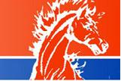
Amos Alonzo Stagg
High School
Certificate
1st place
Lincoln Douglas Debate
JV Division
_______________ _______________
Mike Colletti P. J. Samorian
Tournament Host CCFL President

